Organic Chemistry:

Haloalkanes and Haloarenes:

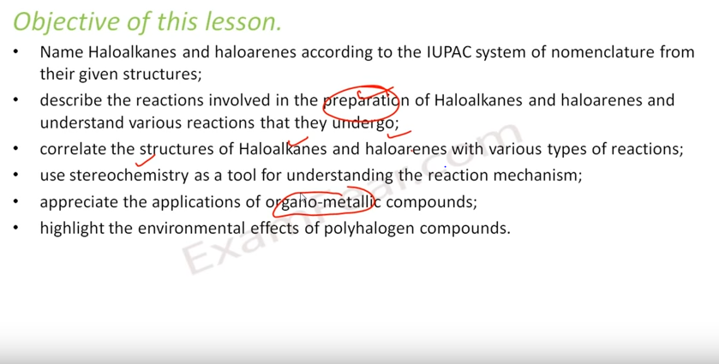

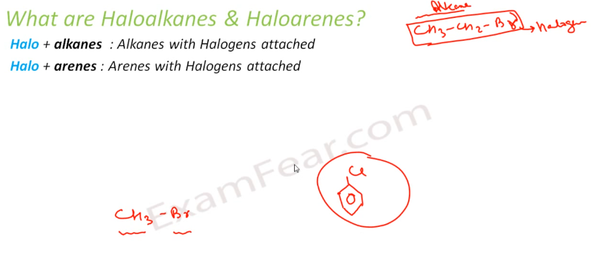

So examples are bromo-ethane,bromo-methane, chloro-benzyn

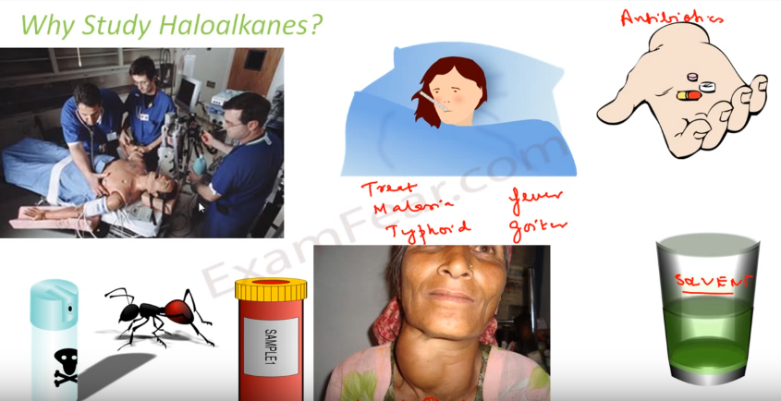

Applications: As good solvent, antibiotics, treatment of malaria and fever goiter, anesthesia.

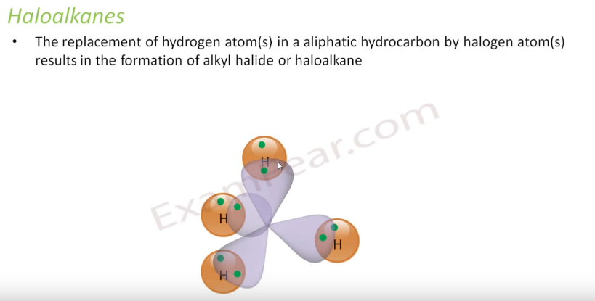

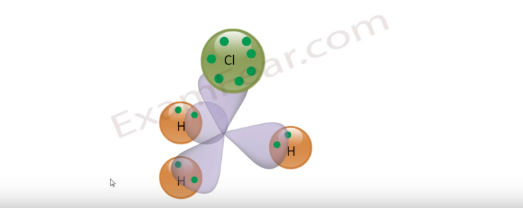

sp3 bonding. 1 or more hydrogen can be replaced with halogens

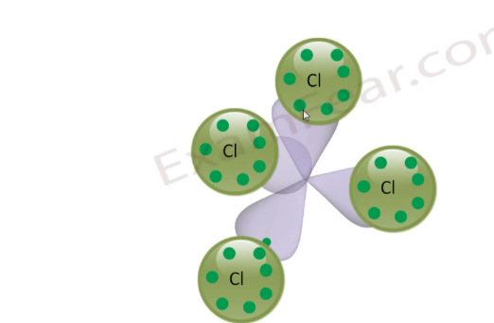

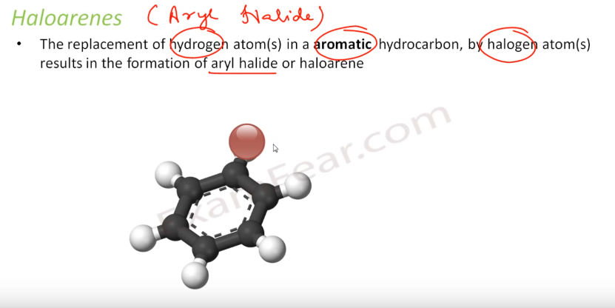

sp2 bond. Again 1 or more hydrogen can be replaced with halogens.

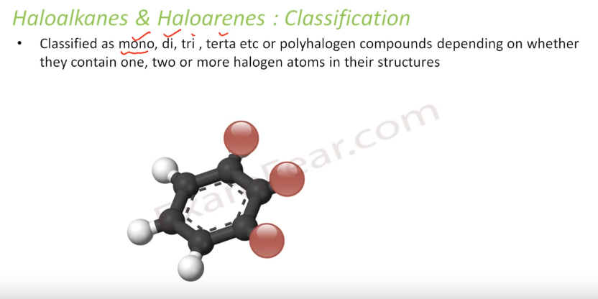

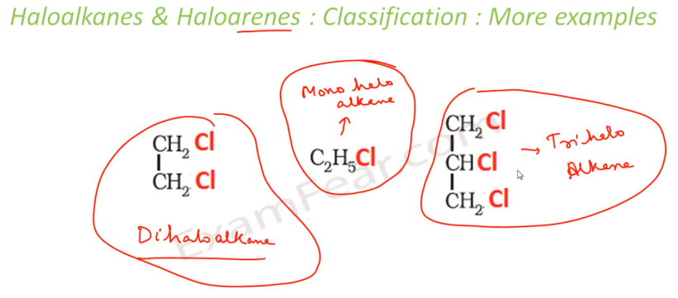

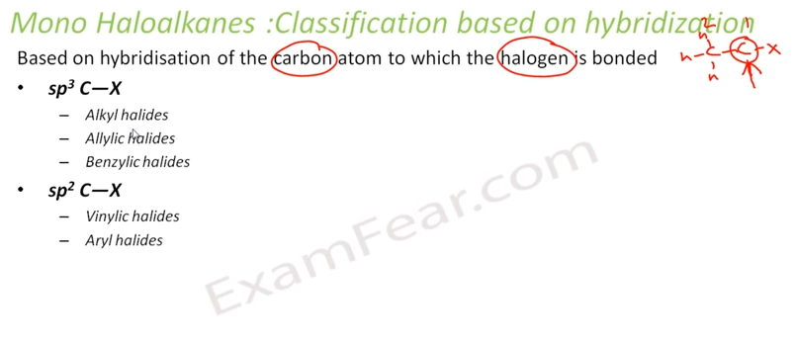

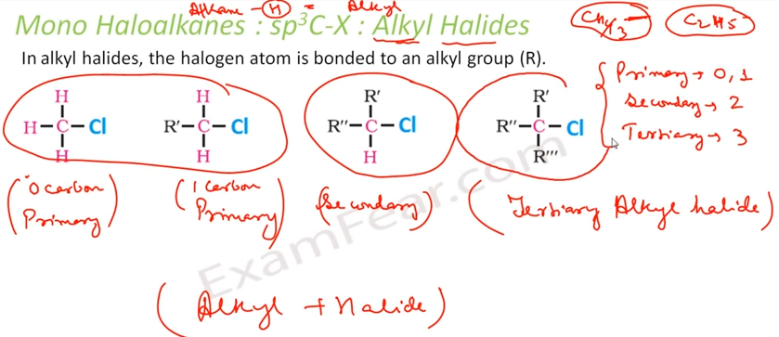

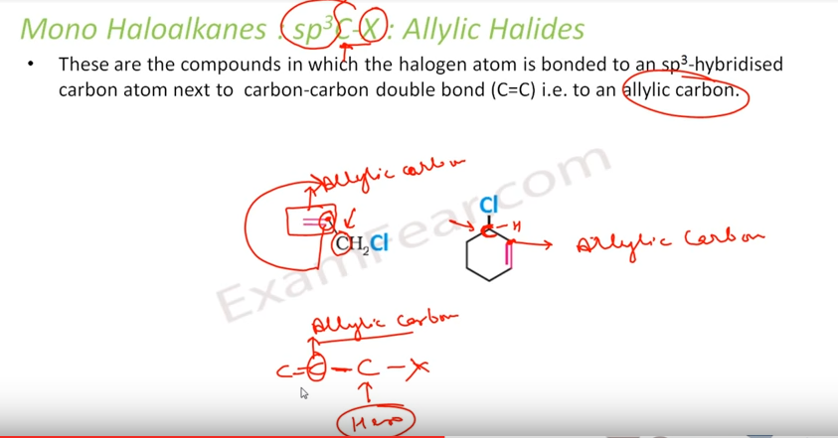

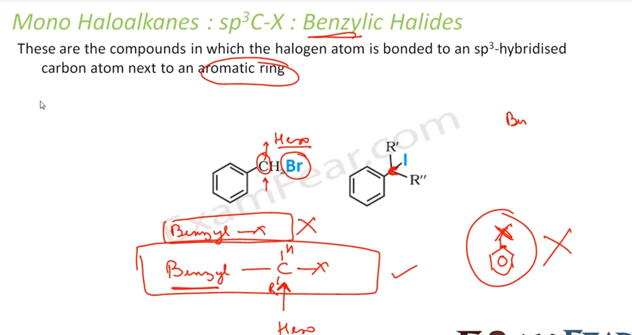

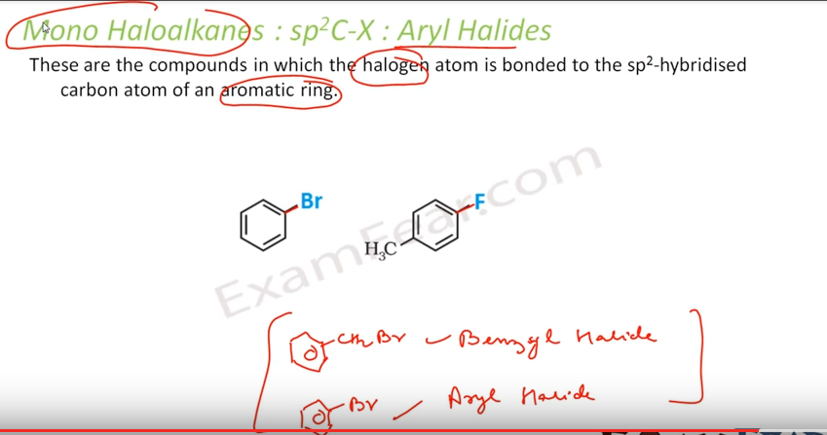

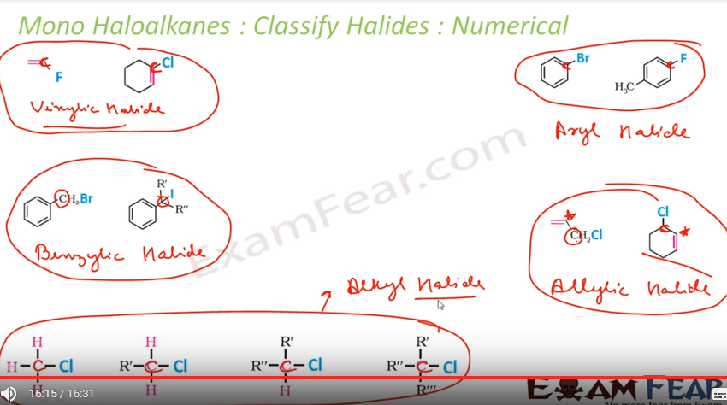

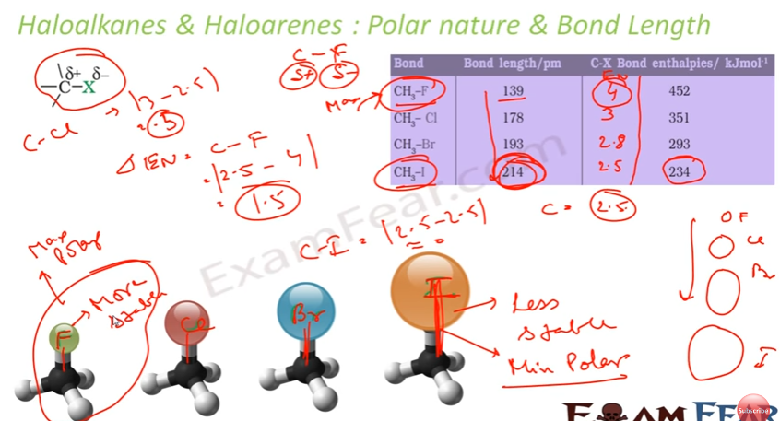

**Nomenclature**

* Nomenclature of halo alkanes
* Select the longest chain of carbon that contains the halogen atom.
* Give least possible number to the halogen atom.
* The carbon containing double or triple bond is given the least number.
* Place the suitable suffix like di, tri, tetra for 2, 3, 4 halogen atoms respectively.
* Name the compounds as halo alkanes, halo alkenes or halo alkynes.
* For example,

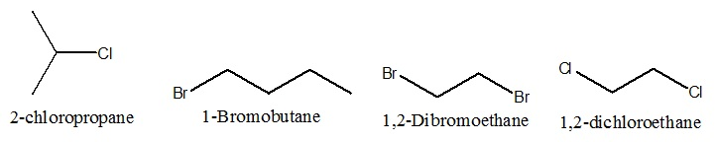

* Nomenclature of halo arenes
* Commonly they are termed aryl halides.
* Numerical prefixes (1,2) ; (1,3) ; (1,4) for [for positions of the compound with respect to halogen atom.
* The halogen atom is given the least number.
* For example,

